This paper came in 2012 for imageNet dataset and used concepts like dropout, relu, gpu’s.

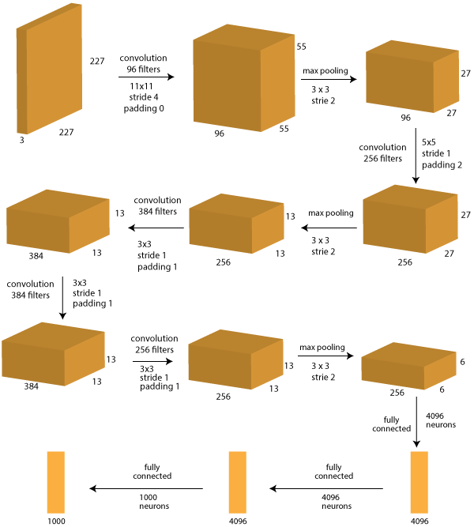

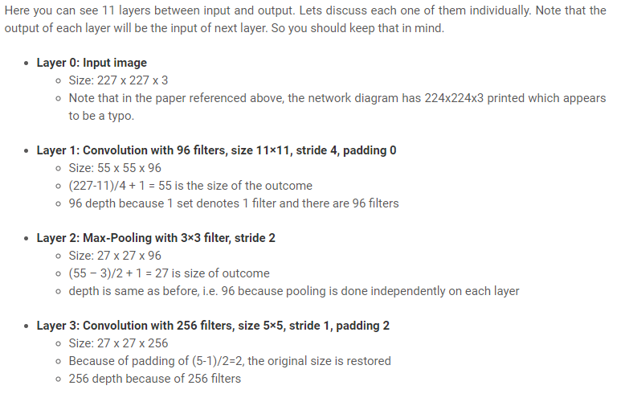

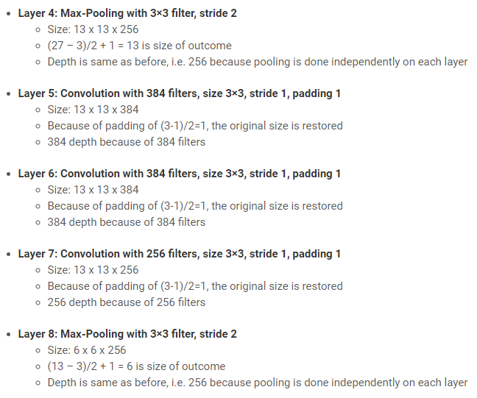

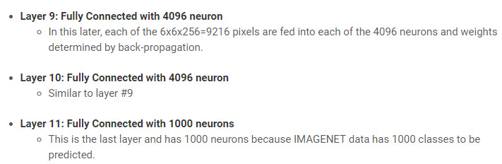

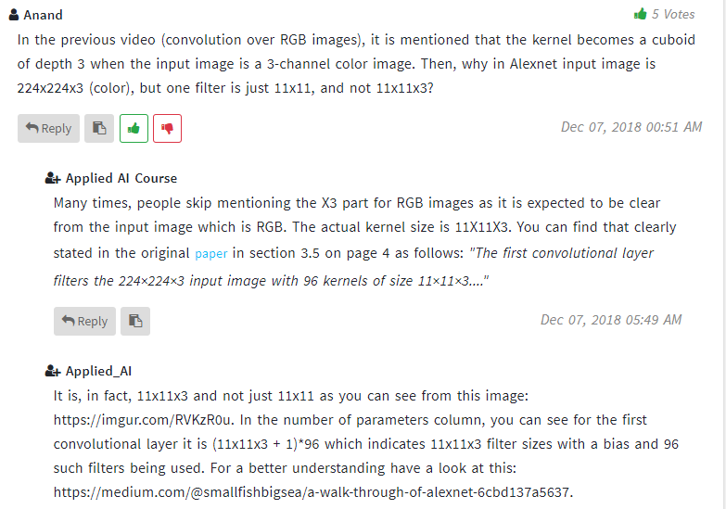

Implementation of alexnet on mnist: <http://euler.stat.yale.edu/~tba3/stat665/lectures/lec18/notebook18.html>

Paper: <http://www.cs.toronto.edu/~fritz/absps/imagenet.pdf>

<https://www.analyticsvidhya.com/blog/2016/04/deep-learning-computer-vision-introduction-convolution-neural-networks/>

data augmentation: <https://github.com/rishabhonline/AlexNet-Image-Segmentation/blob/master/data_augment.py>